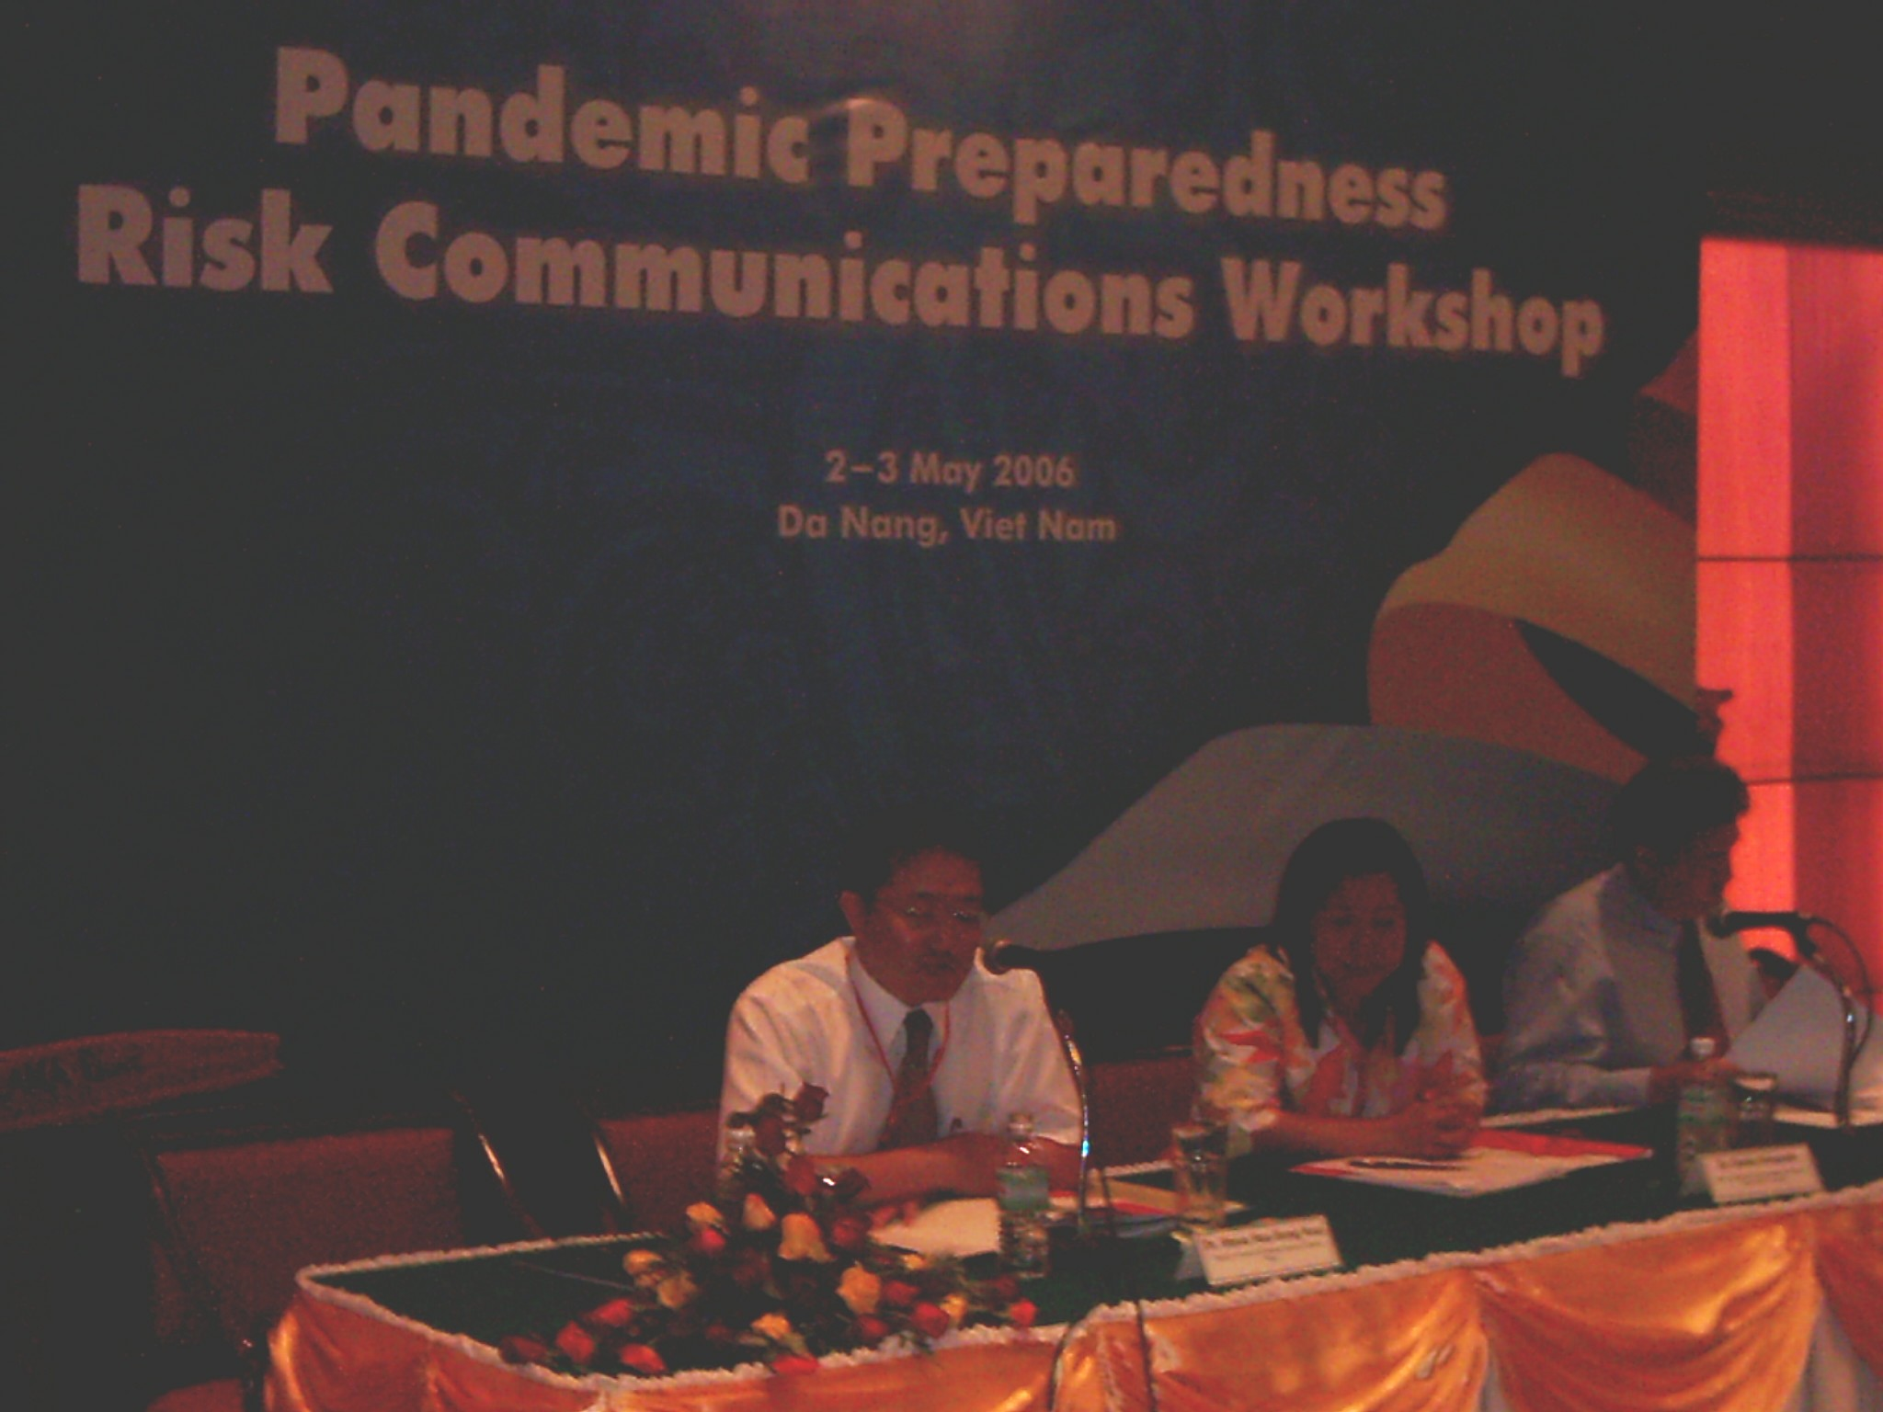
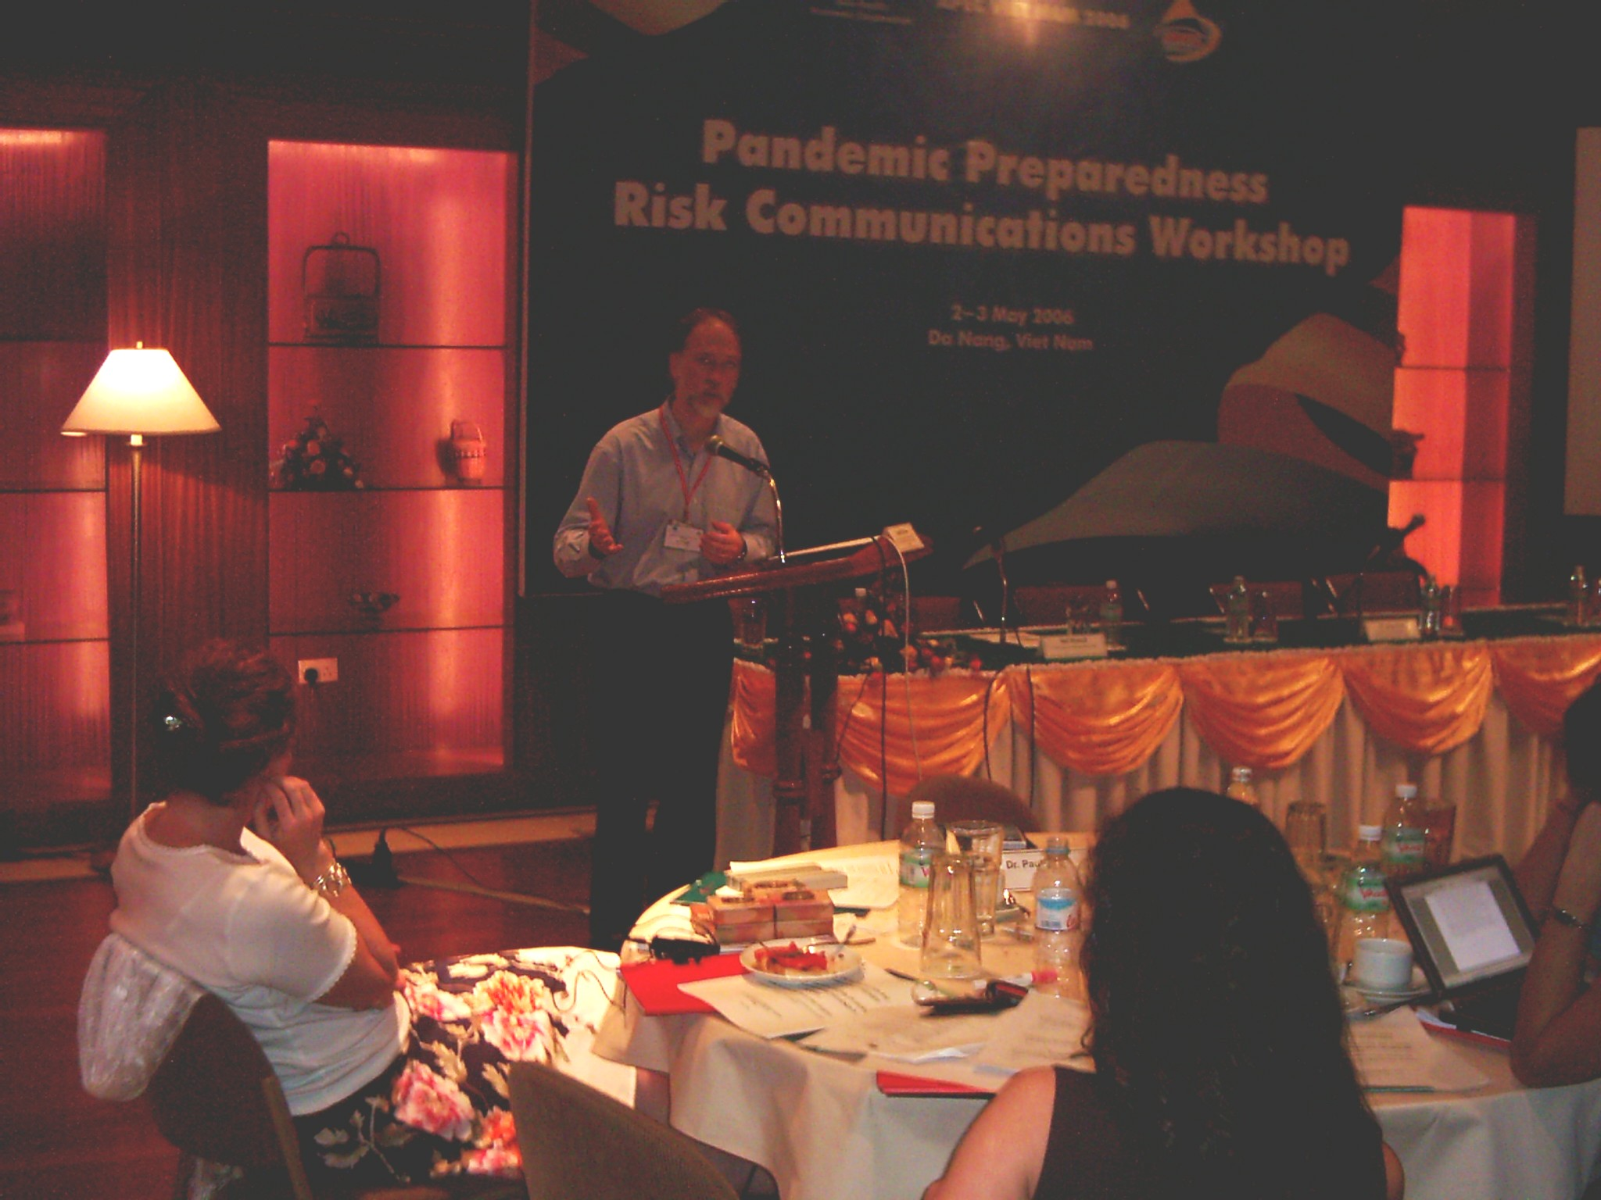
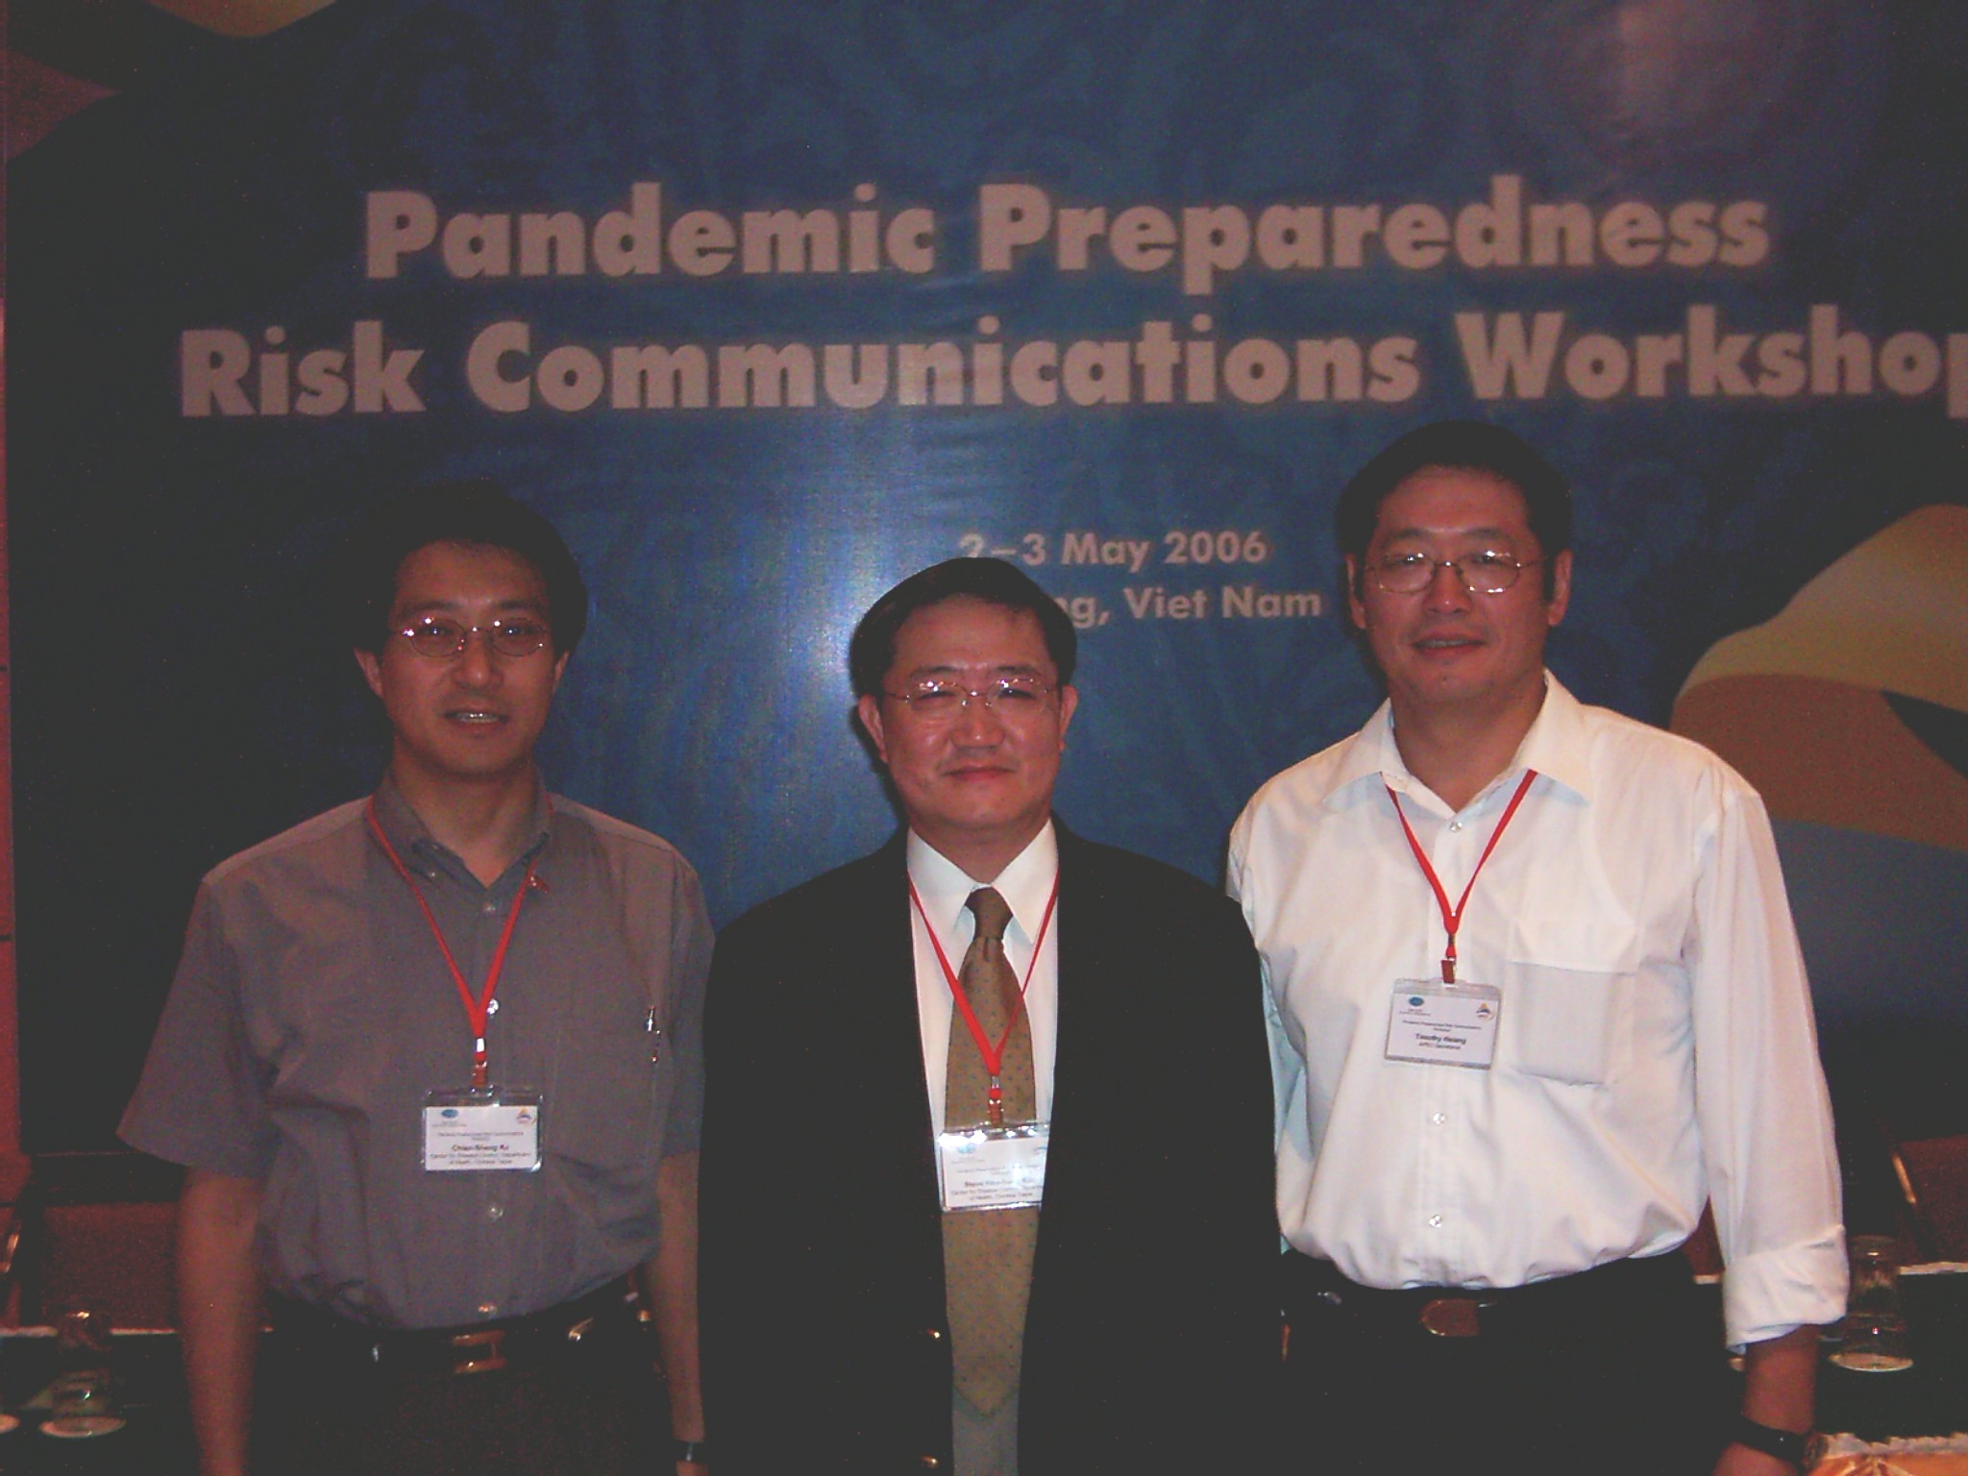
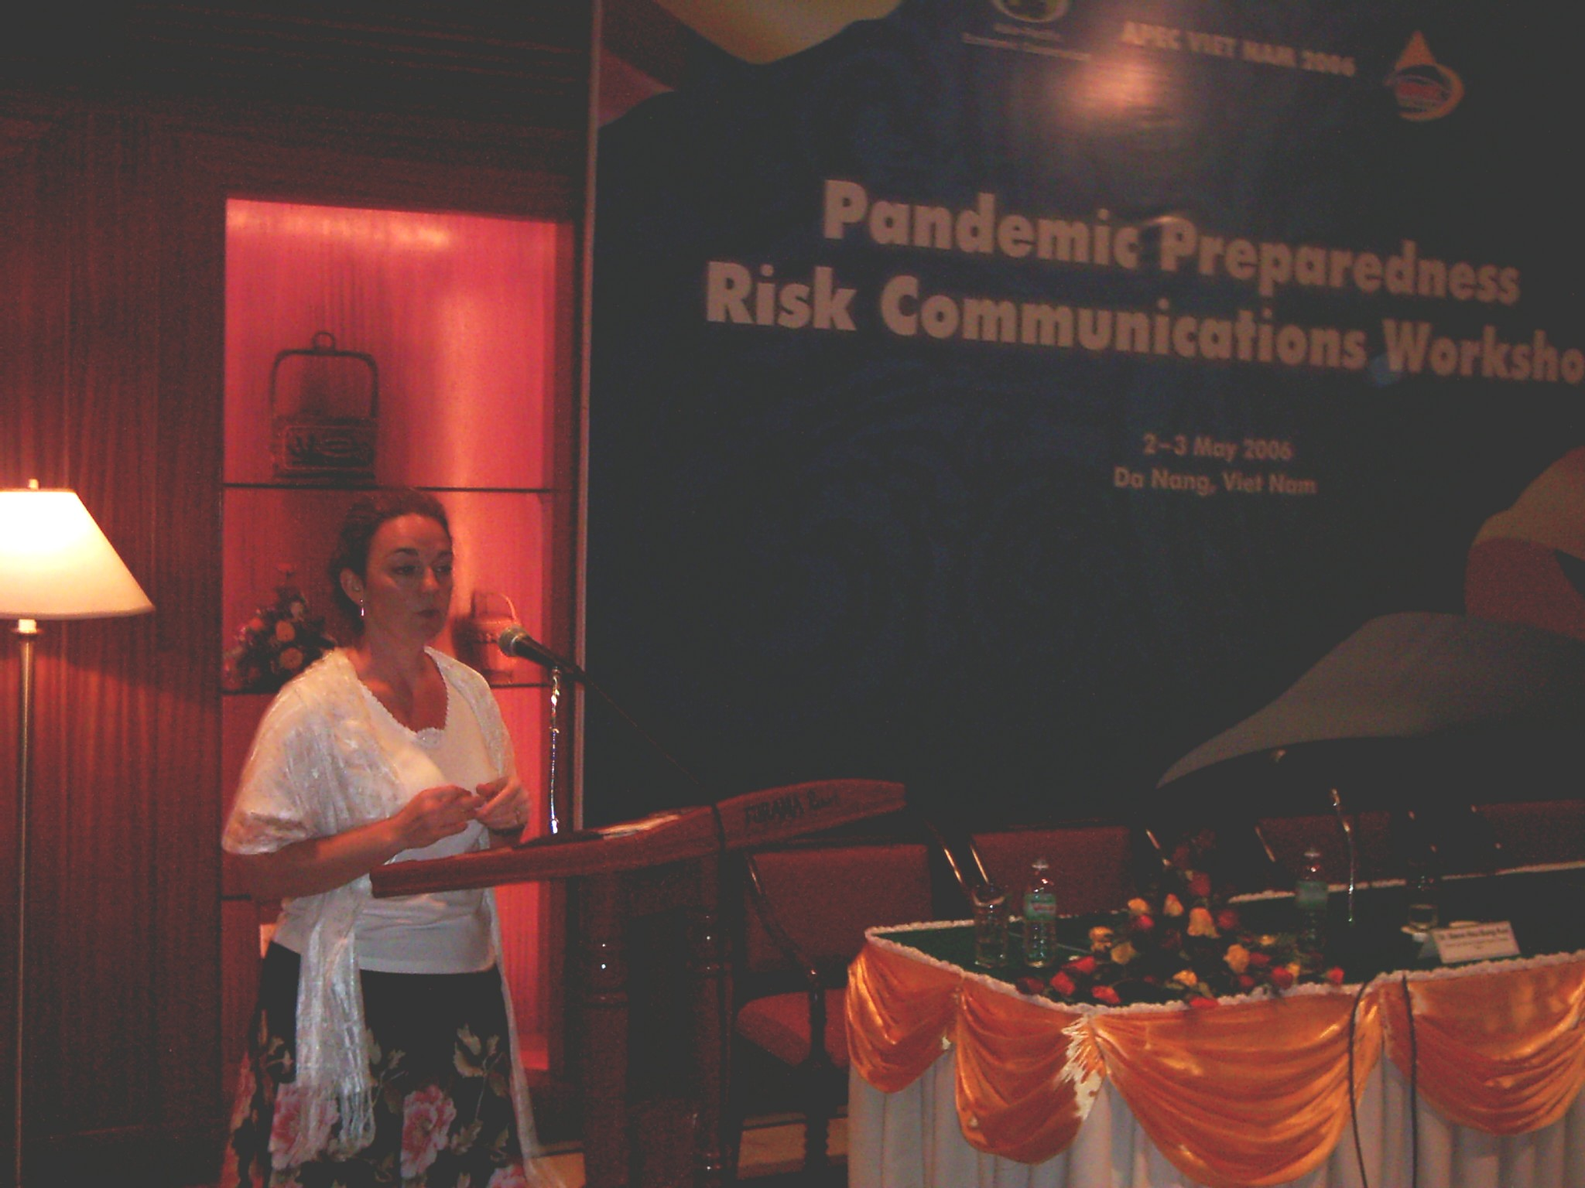
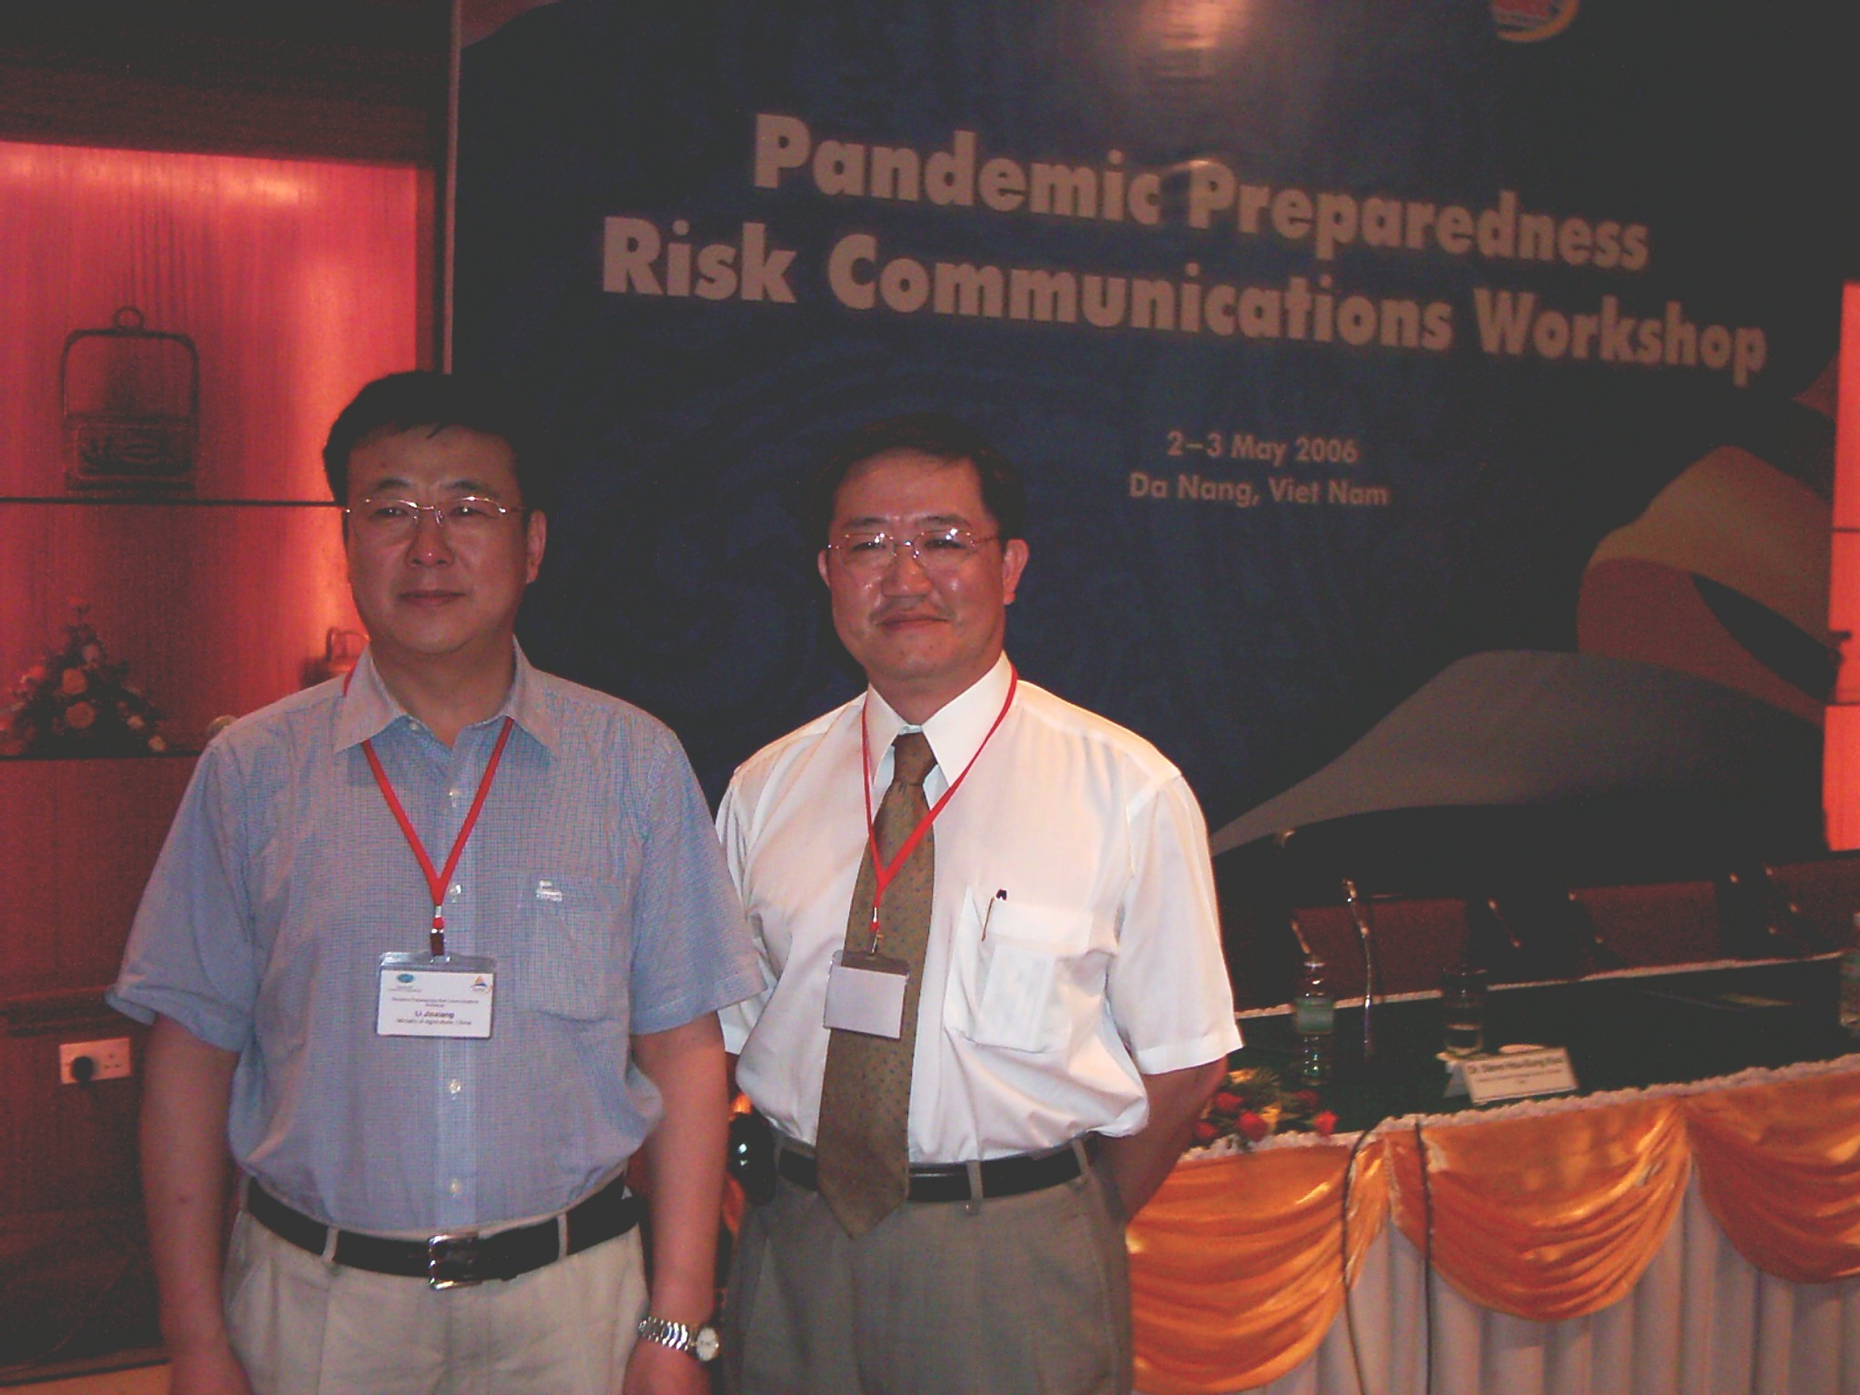
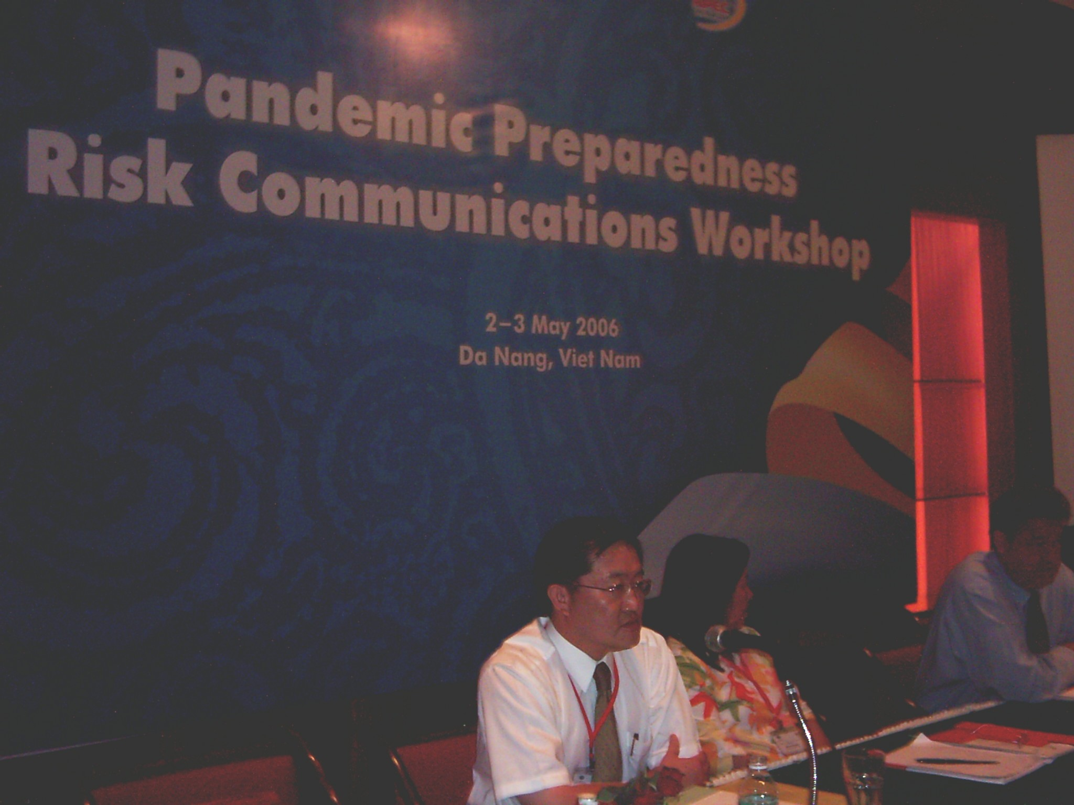
2006.5.2-3 APEC Workshop on Pandemic Preparedness Communications
Director-General of Taiwan CDC, Dr. Steve H.S. Kuo delivered a speech on the topic: Communication during SARS in Taiwan NOT a Success Story, 2006.5.3
Director of Risk Communication of Public Health Agency of Canada Elaine Chatigny
Ian Shugart（Chair, APEC Health Task Force）

Deputy-director of China Veterinary Bureau of Ministry of Agriculture (left) and the Director of Taiwan CDC
Director of the Public Relation of Taiwan CDC (left), Director of Taiwan CDC (center) and the Secretary stationed in APEC

